Holistic Connection

Connecting people through natural living

Winter Apothecary

Recipes

Disclaimer:

All the recipes in this book are for personal use. None of the opinions in this book are those of medical professionals. Taking control of your health is a personal choice. Holistic Connection in no way responsible for your use of these recipes. Please use herbs responsibly and educate yourself and family.

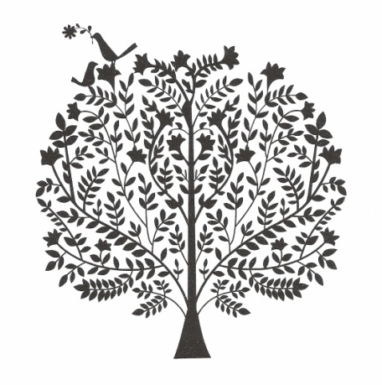

Elderberry Tincture

Dried Elderberries

Alcohol of your choices, vodka, brandy, whisky

Mason Jar

Fill jar with Elderberries. Pour alcohol over the berries. Store in a dark place for 6 weeks. Strain our berries. for long term storage keep in dark glass out of direct light.

Tested Recipe Notes

Grow Your Own

Elderberries are great plants native to Wisconsin. They grow easily and are very easy to propagate. Find a patch with berries that you love- big and plump in mid August -September. In the spring take cuttings from the growing tips and stick them in the ground. Most will take. you can also dip the end in rooting hormone to encourage faster roots. Keep watered.

Note: Uncooked elderberries have a mild toxicity. You can eat some fresh, but don't concentrate them without cooking. For example, don't make fruit leather with uncooked berries! Purple vomit.

Elderberry Syrup

16 oz = 2 cups Water

3 oz = 2/3 C Dried Elderberries

2 TBS Fresh or Dried Ginger Root

1 tsp cinnamon powder or a stick of cinnamon

1/2 tsp cloves or powder

**12 oz = 1 Cup Honey: Reserved for Step 2**

Combine all ingredients except honey. Bring to a simmer on medium flame, simmer on lowest possible flame for 10 minutes covered, remove from heat and let steep for 30 minutes. Strain out solids, let cool to lukewarm, stir in honey.

Store in the fridge, use daily for immune support. 1/2-1 tsp daily for kids, 1/2-1 TBS for adults. If sick, increase dosage to 3-4 times/day.

Cost Estimate: $5.50

Yield: 2.5-3 cups

Introduction

Herbs are a great way to equip yourself to do some basic remedy work at home. Knowing what herbs help with what symptoms is valuable information and can help you in making these recipes altering herbs to suit your specific needs at any given time.

For More information:

Rosemary Gladstar (in your library)

Wellness Mama (online)

For Bulk Herbs:

www.bulkherbstore.com

www.mountainroseherbs.com

Immune Boosting Tea

1 Part Nettle

1 Part Raspberry Leaf

1/2 Part Oat Straw

1/2 Part Alfalfa

1/4 part Red Clover Flower

Mix all the herbs together, put into make your own tea bags or use how you would any other loose leaf tea.

Quick Cough Syrup

2 TBSP Hot Water

1 TBSP Honey

1 TBSP Apple Cider Vinegar

1/4 tsp ginger

1/4 tsp cayenne

Dissolve honey in warmed water, add the rest and shake.

For an additional boost and sleep help, serve with a bit of whiskey.

Herbal Cough Syrup

2 Cups Water infused with 1/2 - 1 Cup of herb mixture

2 Part Herbs: (your largest portions in a ratio)

Elderberry

Slippery Elm

Coltsfoot

Chamomile

1 Part Herbs:

Mullien

Licorice

Thyme

1/2 part Herbs:

Echinacea

Horehound

Burdock

Boil two cups of water, pour over the herbs, cover and steep for 20 minutes. Strain herbs out. Mix one cup water with 1/2 cup honey for a cough syrup. Use the other cup of infused water for the cough drops.

Lozenge Alternative: Take the herb mixture and grind into a powder, mix dry herbs with honey, form into balls and dehydrate.

Eucalyptus Steam

For Congestion

Hot Water, Essential oil

Place hot water in a bowl, add 5 drops essential oil. Put towel over head and bowl. Great for coughs and chest congestion.

Essential Oils

Elderberry Syrup Gummies

9 oz = 1 Cup Elderberry Syrup

4 oz = 1/2 Cup Hot Water (not Boiling)

1.25 oz = 1/4 C Gelatin

Coconut Oil for greasing molds

Glass or silicone dish or molds

Grease Molds. Mix 1/4 Cup Elderberry Syrup with Gelatin, whisk, add hot (not boiling) water, whisk until smooth. Add the rest of the Syrup. Pour into molds, put in the fridge for 2 hours or until completely firm.

Store in the fridge, if layering put parchment between. Take as you would elderberry syrup, increasing the frequency when sick.

Vapor Rub

Basic Salve Recipe:

3.5 oz = 1/2 C oil (olive, almond, coconut)

20 grams beeswax = 2 TBS beeswax Pastilles

20 Drops Eucalyptus Oil

20 Drops Peppermint Oil

10 Drops Rosemary Oil

10 Drops Cinnamon or Clove Oil

Melt Oils and Beeswax together in double boiler ( I like to use a designated ball jar). Add essential oils, stir and pour into containers, metal tins, old film containers, baby food jars...

To use apply to skin directly. For babies and young children you may want to dilute with additional coconut oil.

Herbal Cough Drops

1 Cup Herbal Infused Water (from Syrup Recipe)

1.5 Cups =18 oz Honey

Candy Thermometer

Silicon Molds (coconuts oiled to prevent sticking)

Mix honey and water in a medium sauce pan, on Medium High heat, stir and bring to a simmer and cook until thermometer reads 300° (about 30 minutes)

Pour into candy molds or silicon molds or baking sheet with silicon mat. Let cool until it can be touched and then shape into lozenges. Place on cooling mat or parchment until cooled.

When completely cool, you can dust with stevia and slippery elm powder to keep from getting sticky. Or, wrap individually in parchment.